Aim: Configure Remote Access Authentication Protocol.

# Able to configure and perform remote accessing & routing.

# Duration: 8 Hour.

List of Hardware/Software requirements:

1. Personal Computer
2. Microsoft Windows Server.

# Code/Program/Procedure (with comment):

## Step 1:

Open the virtual machine. And go to the control panel as show below.



## Step 2:

Open the System security.

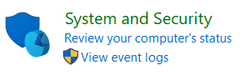

## Step 3:

Know click on system and click on allow remote access.

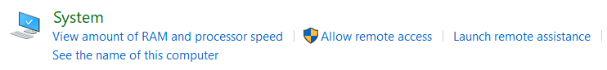

## Step 4:

When you come on system click on remote settings.

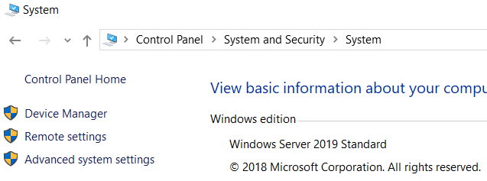

## Step 5:

Know click on allow and tick below option after doing this step simple click on ok.

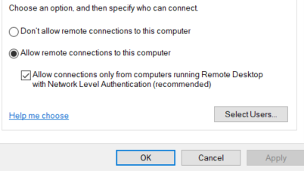

## Step 6:

Go back to system security and go to the allow an app through windows firewall.

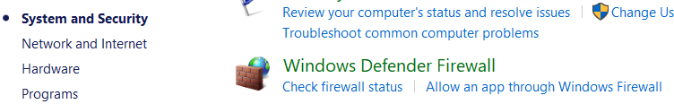

## Step 7:

When you come on allow an app through windows firewall. Then allow the remote desktop make shore private and public both, check and click on cancel

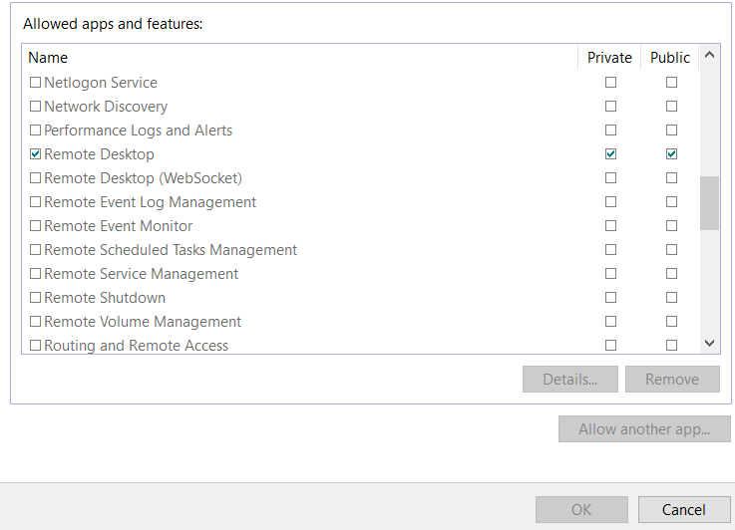

## Step 8:

Close all tabs. Then go to the cmd line and type ipconfig. And note down the IPV4 like (192.168.110.134)

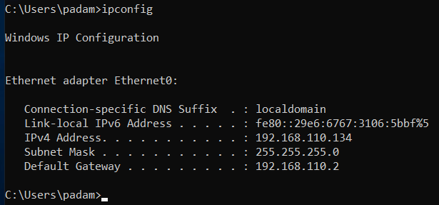

## Step 9:

Go to the physical machine (your real window) go to the remote access and fill the ip add(which you want to connect remotely)

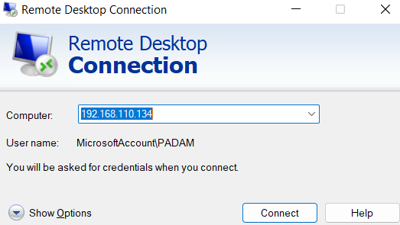

## Step 10:

Enter the use and password then ok. After some time you are connect.

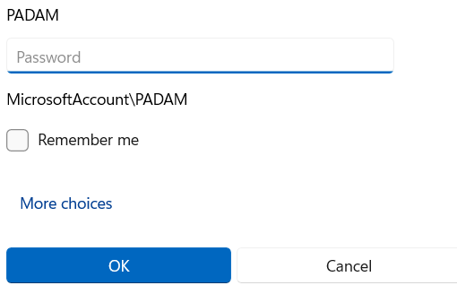

## Step 9:

When you are connected you can see this type of window as show below.

